Nao Nishimura 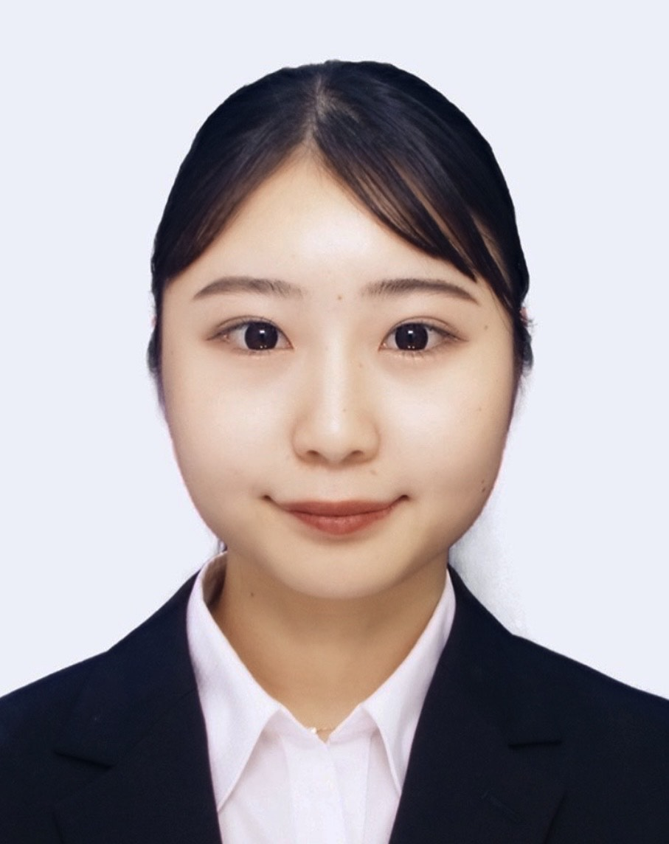

Birth date: 04/06/2001
Languages: Japanese – native, English – Intermediate
Nationality: Japanese
Resides: FUUWA Tokumaru303
2-19-14 Tokumaru, Itabashi-ku, Tokyo, Japan 175-0083

Mobile Phone Number: 080-1967-4399
Email: 20dm059m@rikkyo.ac.jp

Education:
Apr 2020 – Mar 2025
Rikkyo University College of Intercultural, Japan
Bachelor of Intercultural Studies

Aug 2022 – May 2023
St. Cloud State University, United States
Studying Abroad

Qualifications:
- TOEIC 855 (2023)

Technical Skills:
- MS Word, Excel (advanced), PowerPoint

Experience:
Group project Experience
・Completed Global Leadership course- based course associated by Starbucks via English
・Completed group work with non-Japanese and local students which required cross-cultural competency and shared leadership via English

Study Abroad Experience
・Completed all classes
・Participated in project / case studies including marketing, Economy in United States, Social issues in Africa
・Cooperated with students from different backgrounds and different ages to effectively carry out presentations and business analysis which required leadership and a flexible mindset

Internship Experience
・Completed a six-month long-term internship and achieved the No.1 in single-month sales of custom-made suits in the organization during my second year of college
・Participated in the equipment and management team with Indian engineers for an IT company during my third year of college
・Currently participating in a long-term internship at an employment agency

