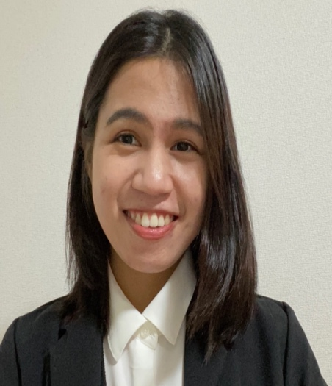

Sachiko Ponpon

Educator, B2B Sales

Dynamic and result-driven professional with 2 years of experience in boosting student enrollment and driving sales of educational materials and course, backed by a strong background in teaching. Expert in prospecting and converting leads into satisfied students. Possesses exceptional written and oral communication skills in English, and proficient in Japanese (N3 Level).

Areas of Expertise:

* Excellent in verbal and written communication
* Direct Sales
* Team Work
* Organization and Time Management

Languages:

* Tagalog (Native)
* English (Native/ Bilingual Proficiency Level)
* Japanese (Daily Conversation Level, JLPT N3)

Certifications:

* (January 2023)

CPD Certification for Recruitment Consultant at Alison (Online Course)

* (January 2023)

Japanese Language Proficiency N3

* (August 2021)

Test of Initial Capability for ALTs at Link Interac

* (August 2021)

English for Journalism (online course) at University of Pennsylvania

Work Experience:

**Amity Corporation**

Educator, B2B Sales | April 2022 – Present | Full Time

* Reached 71% assigned goal through direct sales of courses and materials accommodating student’s language level and needs.
* Delivered 120% branch rate in successful marketing plan and research in achieving seasonal event classes
* Interviewed prospective Japanese teachers to evaluate their English capabilities for 20 – 30 minutes.

**Interac Kanto South Co., Ltd**

Assistant Language Teacher | April 2021 – March 2022 | Full Time

* Collaborated with co-teacher for English camp with 10 -15 young learners
* Presented world culture and integrating grammar pattern to encourage the relevance of English in our daily life to young learners
* Provided 20 minutes conversation activities to young learners to be more confident and to develop their speaking skills

**Interac Kansai & South-Central Co., Ltd**

Assistant Language Teacher | September 2018 – March 2021 | Full Time

* Executed intensive training for junior high school participants for National English Speech Contest, one of the participants won the Speech contest under my supervision
* Assisted in making questions for essay English tests with the head teacher
* Shared administrative tasks with the head teacher

Education:

**Mindanao Kokusai Daigaku**

Bachelor of Science in International Studies

June 2013 – March 2017

School Associations:

* Student Council: Public Information Officer
* Literary Contributor of School Publication
* Member of Music Club
* Member of Debate Club

Awards:

* Leadership Training Seminar and Earned a Community Service Awards
* Champion in Oratorical Speech Competition in 2014
* 2nd place in Poetry Interpretation with the theme of “Sustaining the Skills and Competencies Towards ASEAN” in 2015
* 1st place in Japanese Speech Competition in 2016
* Outstanding Thesis: Suitability of Ecotourism Destinations in Davao Region Using GSIS Method in 2016
* Hip-hop Dance Competition as Champion in 2014 and 2017
* Dean’s Lister during the school year of 2015 – 2016 with a score of 3.36 and also, during the school year of 2016 – 2017 with a score of 3.28

Extra – Curricular Activities:

* Broadway Music Student at Muzic’s Kool

Personal Information:

ponponsachiko23@gmail.com



080-9725-1196



254-0044, 11-4 Nishikicho, Hiratsuka-shi, Kanagawa ken



Long Term Resident